**How to Install VirtualBox and Windows on your Mac**

If you’re a Mac user, there’s no need to sell your Mac and get a Windows computer. You can use VirtualBox, [Parallels](http://www.onthehub.com/parallels)or [VMWare](http://store.vmware.com/academic) (links lead to academic versions) to run Windows on your Mac. This tutorial was written for VirtualBox, since it’s free and you don’t have to reboot your computer to access Windows (this is why I don’t recommend [Bootcamp](https://support.apple.com/boot-camp), since you lose access to your Mac files and software).

Before you do anything else, make sure your Mac is updated to the latest version of OS X your computer supports, and verify it has 8GB or more of RAM. You will need to purchase a Windows 10 Home (64-bit) license, which is [available new on Amazon](https://www.amazon.com/s/ref=nb_sb_noss?url=search-alias%3Daps&field-keywords=Microsoft+Windows+10+Home+64+Bit+OEM) (search for “Microsoft Windows 10 Home 64 Bit OEM”) or a [second-hand license available on eBay](https://www.ebay.com/sch/i.html?_nkw=Microsoft+Windows+10+Home+64+Bit+OEM). What you really need is the activation key, since DVD drives are very uncommon and you can [download an ISO of the installation disk](https://www.microsoft.com/en-us/software-download/windows10ISO) directly from Microsoft. If you accidentally purchase a DVD you would need to use an external DVD drive, which can be purchased, or borrowed from a classmate.

**1) Download VirtualBox**

<https://www.virtualbox.org/wiki/Downloads>

Save the DMG to a location on your computer where you will be able to find it (Downloads, Desktop, etc.). If you are on a Mac, you need the version for “OS X hosts.”

**2) Install VirtualBox**

VirtualBox must be installed before it can be used. When you mount the DMG, you must then run the VirtualBox installer, which will place VirtualBox into your Applications folder.

[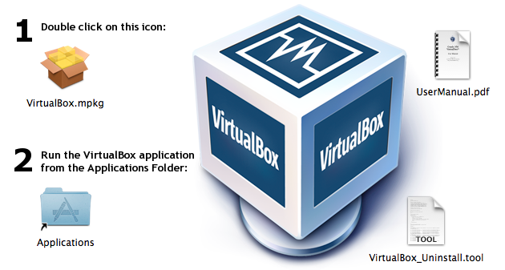](http://sites.miis.edu/kb/files/2012/06/VB-02.png)

**3) Create your Virtual Machine (VM)**

1. When you run VirtualBox for the first time, there will be no virtual machines (VMs) installed.  
   [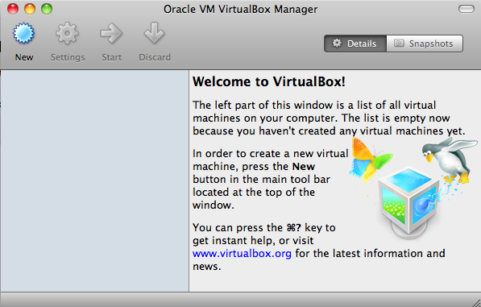](http://sites.miis.edu/kb/files/2012/06/VB-03.png)
2. Click New in the toolbar, which will launch the New Virtual Machine Wizard.
   1. Give your VM a name such as “Windows 10”.
   2. Select “Windows” as the operating system, and “Windows 10 (64 bit)” as the version.
   3. Go with the recommended memory (2048 MB, or 2 GB).
   4. Leave the default “Create a virtual hard disk now” selected.
   5. Choose “Create.”
3. Next you must configure the hard disk for your VM to use. The default settings should be fine (the drive is dynamic, so will only use the least amount of space on your host computer). Choose “Create.”
4. You will now be taken back to the Virtual Machine Manager, which will no longer be empty. You should see the VM you created, and it should be “Powered Off”. Your VM is a computer within a computer, which means it must be started and shut down like a normal computer (it also means it can get viruses so be careful).  
   [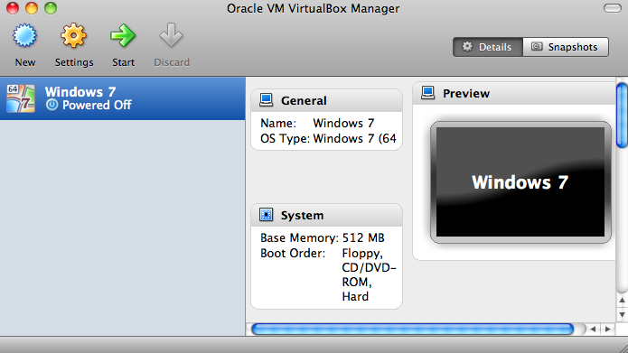](http://sites.miis.edu/kb/files/2012/06/VB-07.png)

**5) Install Windows**

1. Click the green “Start” arrow.  
   [Click "Start"](http://sites.miis.edu/kb/files/2012/06/VB-08.png)  
   You will see a warning that “Auto capture keyboard” is turned on. What is important to note on this screen is the host key, which is set to Left Command key. Use this key to “release” the mouse and keyboard from the VM to switch back to your Mac. You will need to do this if your mouse and keyboard appear to be “stuck” in the VM, meaning you can’t move the mouse out of the VM. Normally after Windows installed, you can simply move your mouse out of the VM window and it will be back on your Mac side.
2. Since you haven’t yet installed Windows, you will be taken into the “First Run Wizard”, which will help you install Windows.  
   [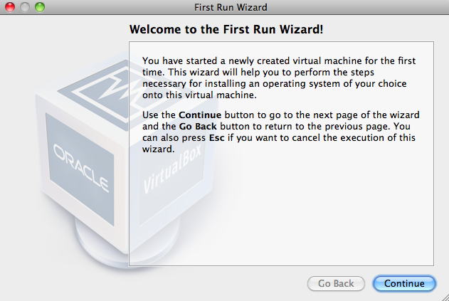](http://sites.miis.edu/kb/files/2012/06/VB-09.png)  
   Click “Continue” to get started.
3. Make sure you know where the ISO Windows 10 installation ISO is located (or you are using the installation DVD). Select the installation media in the drop down list and select “Continue”. If your computer does not have a CD/DVD drive, you may install an OS from disk media by clicking the folder browser icon (to the right below). Navigate to an installation image – DMG, ISO, CDR, DMG and select “Open”.  
   [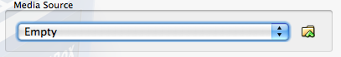](http://sites.miis.edu/kb/files/2012/06/VB-10.png)
4. If you have successfully selected your installation media, you will be presented with a Summary screen. Verify that the information is correct and select “Start”.
5. Your VM should start for the first time. It will boot like a normal computer, but in a window on your Mac. You may get the Virtual Machine host key warning again, select “Do not show this message again” and then “Capture”. You must remember your host key, which defaults to the left Command key.  
   [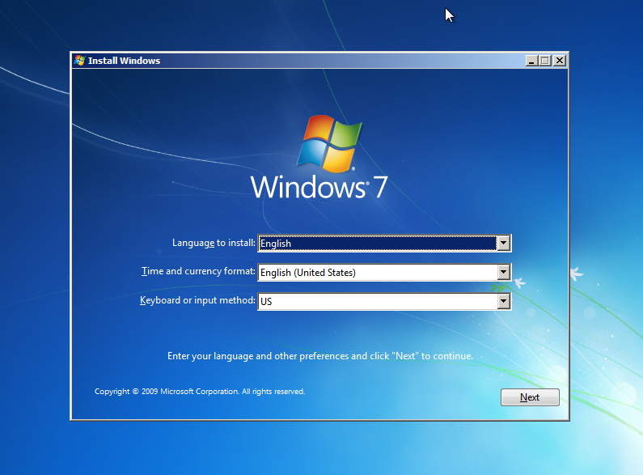](http://sites.miis.edu/kb/files/2012/06/VB-11.png)
6. Now you are in the Windows installer. Follow the on-screen instructions, the default settings should be fine. One screen that is a little confusing is the “Upgrade” or “Custom” installation. Since this is a new VM, there is nothing to upgrade, so Custom would be the most logical choice.

Your VM may reboot a few times as Windows in installed, but most of your time will be spent watching your screen, so this would be a good time to get up and walk around.

**6) Configure a Shared Folder**

Before you can actually use your new VM, you will need to enable a shared folder. This folder is used to access files on your Mac from your VM. If you don’t have a shared folder, then your VM will be landlocked, meaning you won’t be able to get files on or off (you could theoretically use a USB key). To configure a shared folder, your VM must be powered off.

1. In your VM configuration window, scroll down to the Shared Folders section. Clicking this heading will open the shared folders Window.  
   [Shared Folders](http://sites.miis.edu/kb/files/2012/06/VB-12.png)
2. Click the “Add a new shared folder definition” button [Button](http://sites.miis.edu/kb/files/2012/06/VB-13.png) to add a share.
3. Click the down arrow in the folder path box and select “Other…”. Navigate to a folder on your Mac, such as your Desktop or your Documents folder. Once you have chosen your folder, click “Choose”.
4. The folder name will automatically populate the “Folder Name” box, but you can change it should you wish. Make sure “Read-only” is not checked, and that “Auto-mount” is checked.  
   [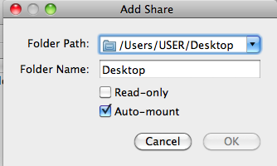](http://sites.miis.edu/kb/files/2012/06/VB-14.png)

**7) Guest Additions**

Start up your VM, when it is finished booting and you have added a user account, your final step is to install some software that VirtualBox will use to make using your VM perform a little better. From the “Devices” menu, select “Install Guest Additions”.

[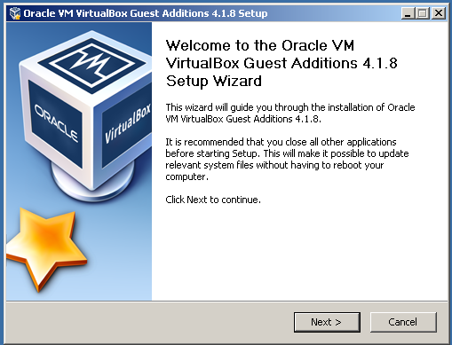](http://sites.miis.edu/kb/files/2012/06/VB-15.png)

**8) Use your VM!**

You have now successfully installed VirtualBox and Windows. You may now install other software that you will need for courses. If you attached a USB key (or insert a CD or DVD into your computer), you may use it in your VM. You can also install software you download from the internet. Usually installation software ends with the extension .exe. These files can safely be downloaded on your Mac to be used in your VM. Your Mac will ignore them since .exe files are not compatible.

You will need to have Office on either your Mac or PC. Some software may require Office to be installed on Windows.

If you have any questions, please refer to the VirtualBox user manual: <https://www.virtualbox.org/manual/UserManual.html>